SUMMARY

1.Properties of an estimator:

* Let  such that  is a parameter.
* Let is an estimator of .
* We have some properties  as following:

1.  is an unbiased estimator of  if 
2.  is an efficient estimator of  if 
3. Cramer-Rao Lower Bound (CRLB): gives the lower estimate for the variance of an unbiased estimator

We use only one density function

 with 

We use likelihood function

Let  , then

 with 

1.  is a consistent estimator of  if 
2. Central Limit Theorem



II. Maximum Likelihood Estimator(MLE)

* Let  such that  is a parameter.
* Let 
* MLE, 

Example1.

1. Let , then 
2. Let , then 
3. Let , then 

Example2. Calculate the Expected value and Variance of the estimator is Example1.

* Properties of MLE

1. MLE() is an unbiased, efficient and consistent estimator of 
2. MLE() reaches(more or less) the CRLB
3. CLT
4. Let  be the (in Bernoulli), (in Poisson) or (in Normal), then



1. CLT for 

The MLE of  is  which is biased estimator.

Let , then is an unbiased estimator of .

We have



Remark: We use CTL to construct the Confidence Interval.

III. Confidence Interval

* Suppose that is known, e.g . It is called Confidence Level.
* Definition: given with *a* < *b* , then [*a, b*] is called (1-) confidence interval for parameter  if .

1. Confidence Interval for means with known 

* Suppose that  such that is known. Our aim: to estimate .
* Point estimator for  is .
* We want now to construct the Confidence Interval (Interval Estimation) for .
* We know that 
* CLT, 
* 95% confidence interval for parameter is 
* General: (1-) confidence interval for parameter is 
* Example:

1. Let X equal the length of life of a 60-watt light bulb marketed by a certain manufacturer. Assume that the distribution of X is N(μ, 1296). If a random sample of n = 27 bulbs is tested until they burn out, yielding a sample mean of hours. a.1 What is the point estimator for .

a.2 Construct a95% confidence interval for μ

a.3 Construct a90% confidence interval for μ

a.4 Interpret the result in a.3

b. Lake Macatawa, an inlet lake on the east side of Lake Michigan, is divided into an  
east basin and a west basin. To measure the effect on the lake of salting city streets in  
the winter, students took 32 samples of water from the west basin and measured the  
amount of sodium in parts per million in order to make a statistical inference about  
the unknown mean *μ*. They obtained the following data:

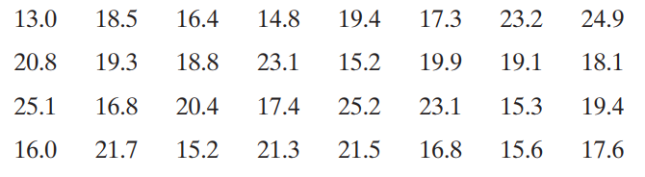

b.1 Construct a95% confidence interval for μ if 

b.2 Construct a95% confidence interval for μ if is unknown

1. Confidence Interval for means with unknown 

We use Student distribution

1. Confidence Interval for 

We use Chi-Square distribution